# TASK_2_PROBLEM_STATEMENT_2_ SQL

1. Create a table named ‘matches’ with appropriate data types for columns

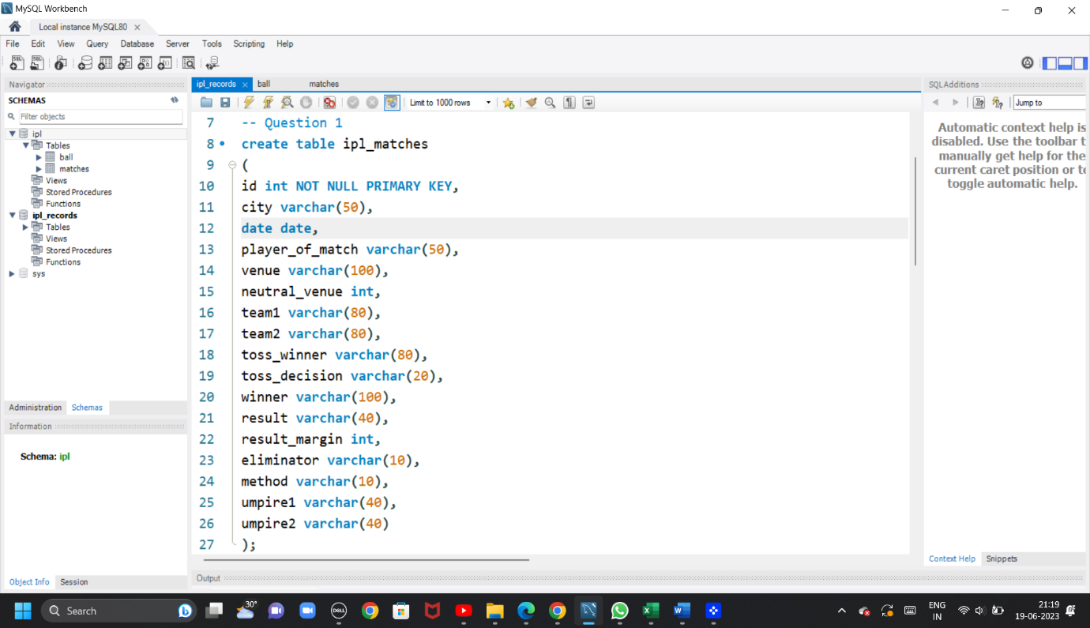

2. Create a table named ‘deliveries’ with appropriate data types for columns.

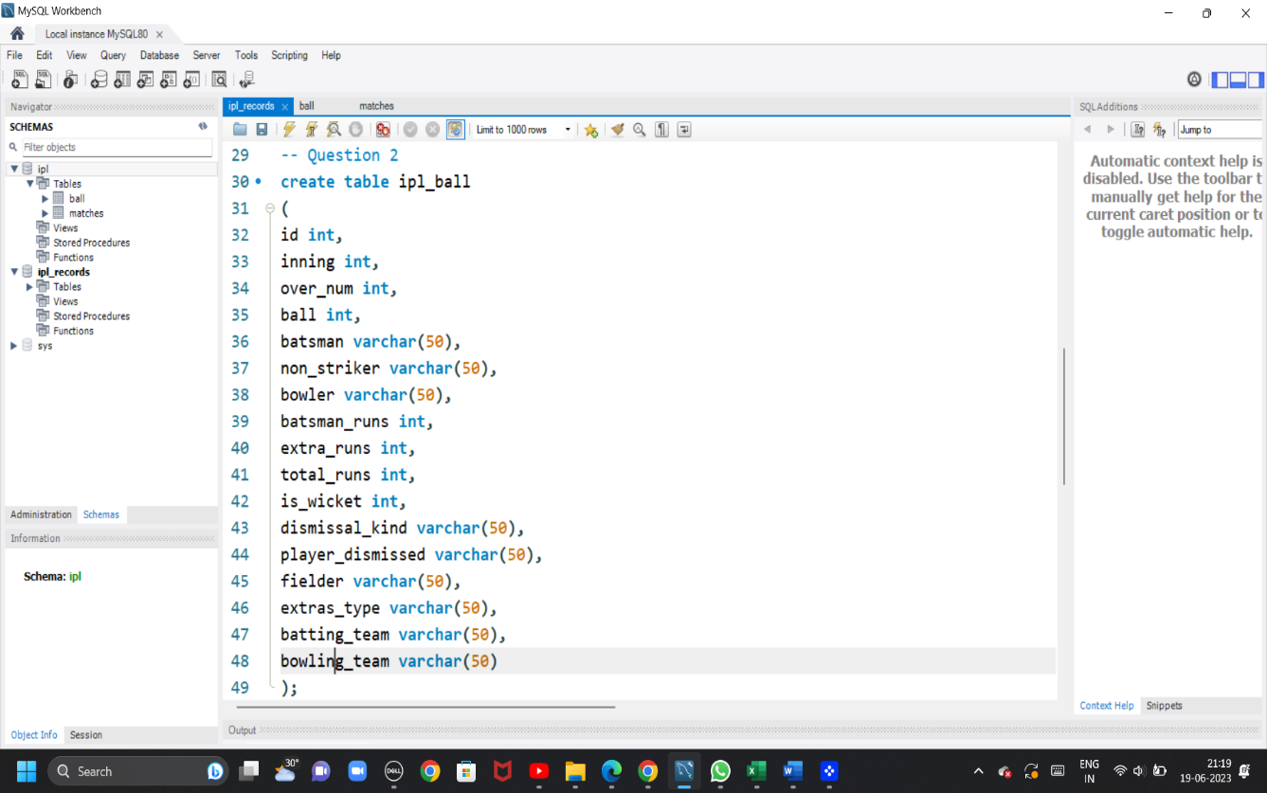

3. Import data from CSV file ’IPL_matches.csv’ attached in resources to ‘matches’

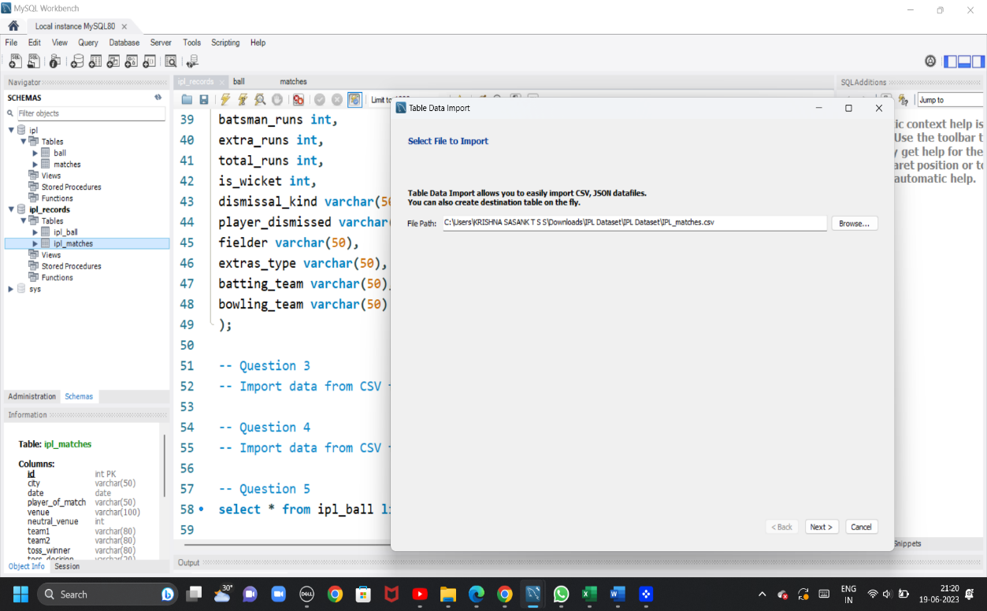

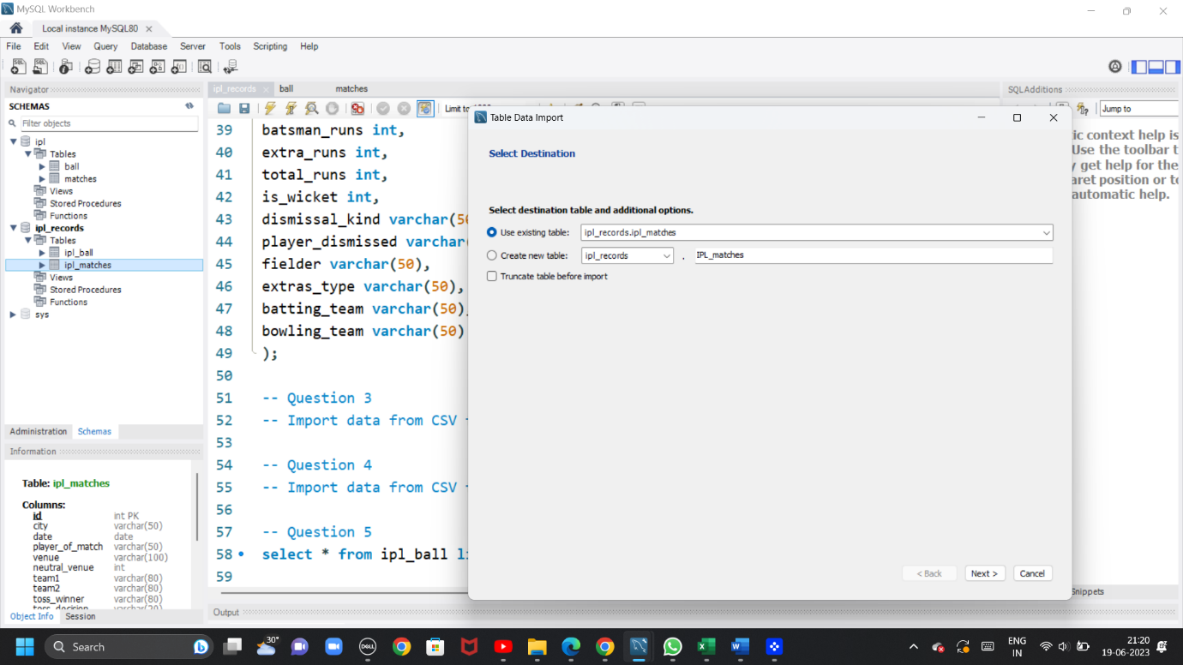

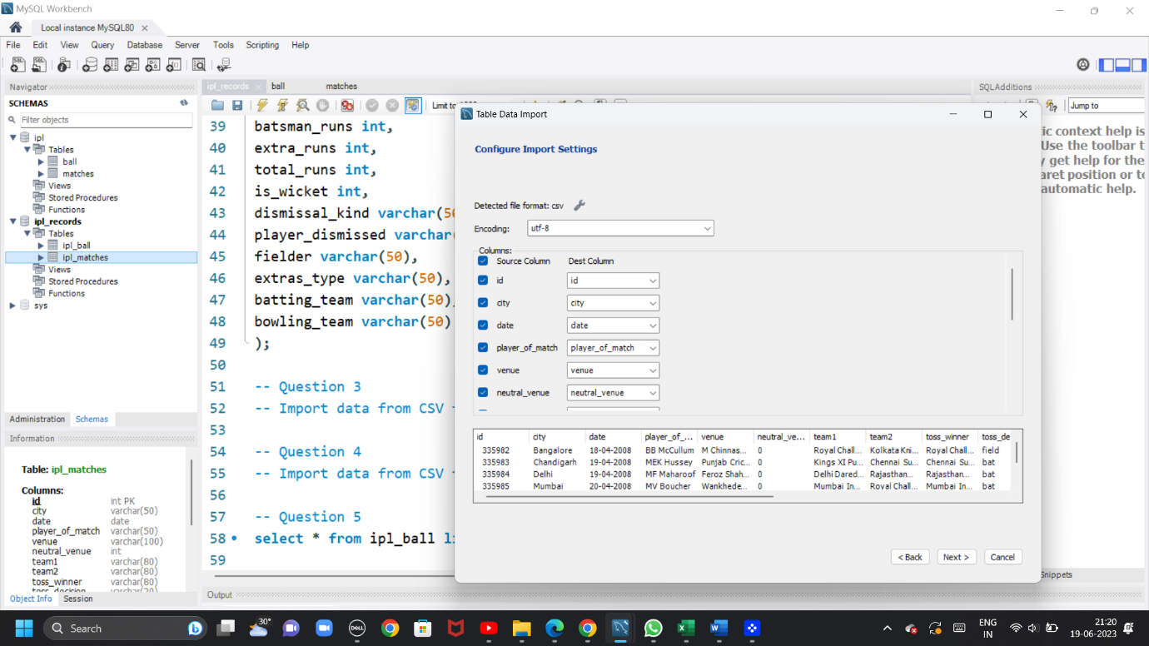

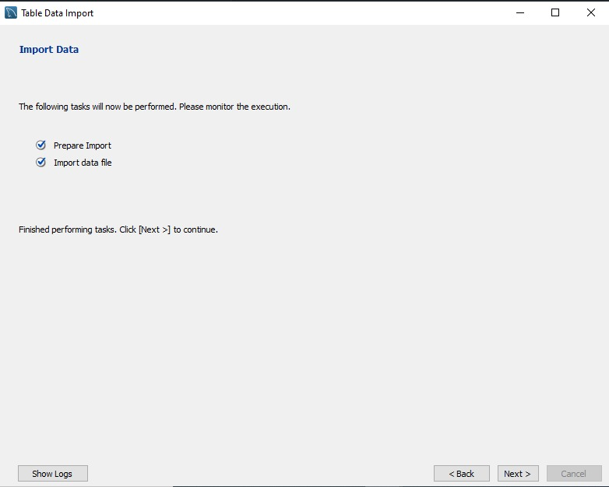

4. Import data from CSV file ’IPL_Ball.csv’ attached in resources to ‘deliveries’

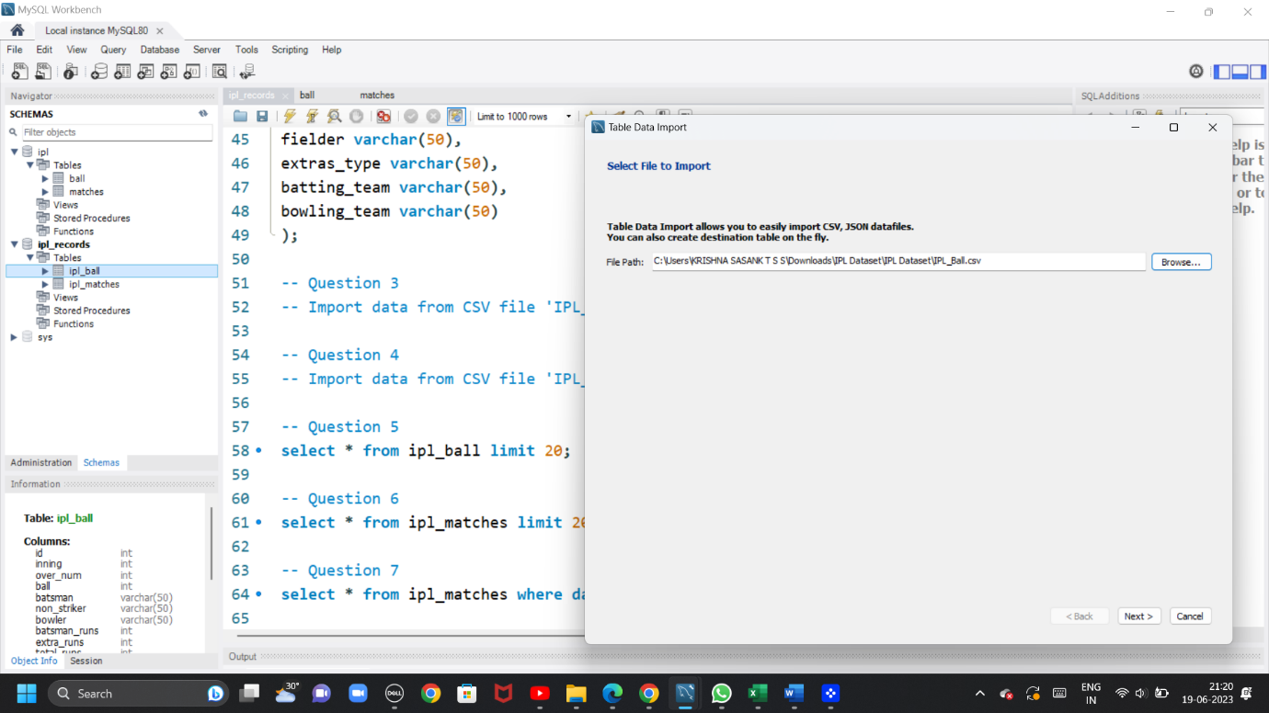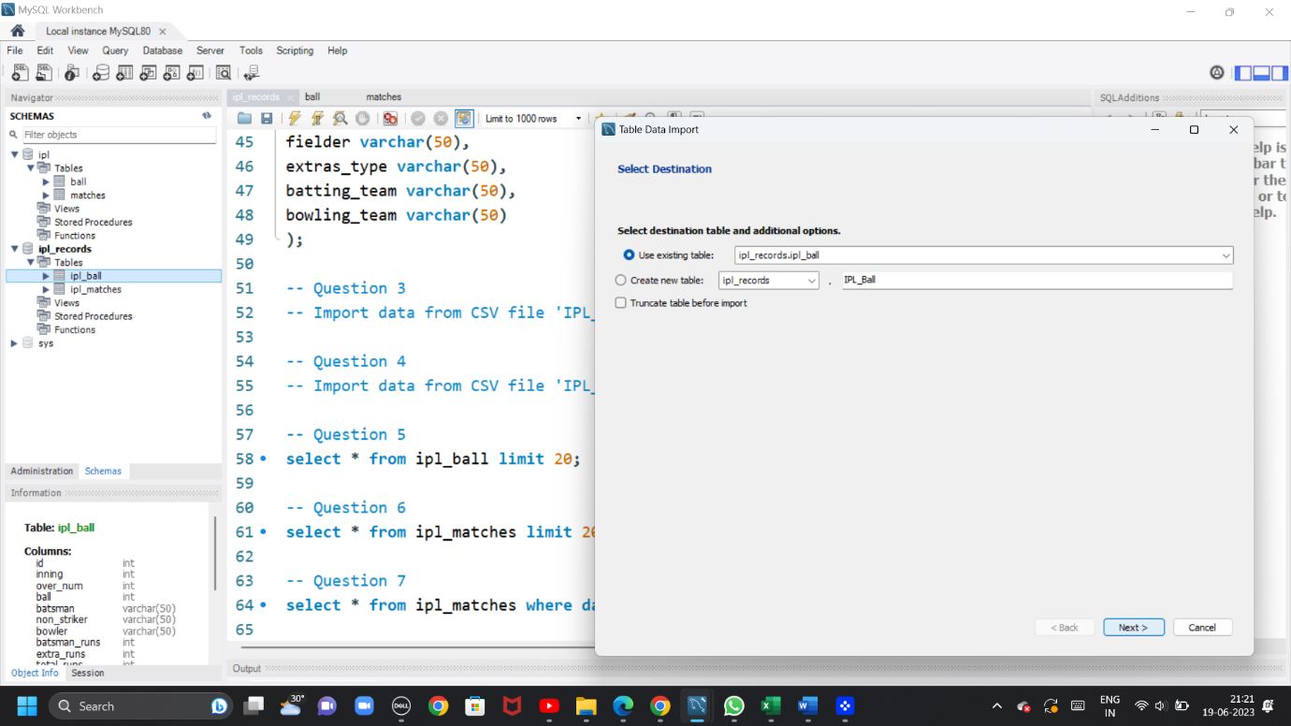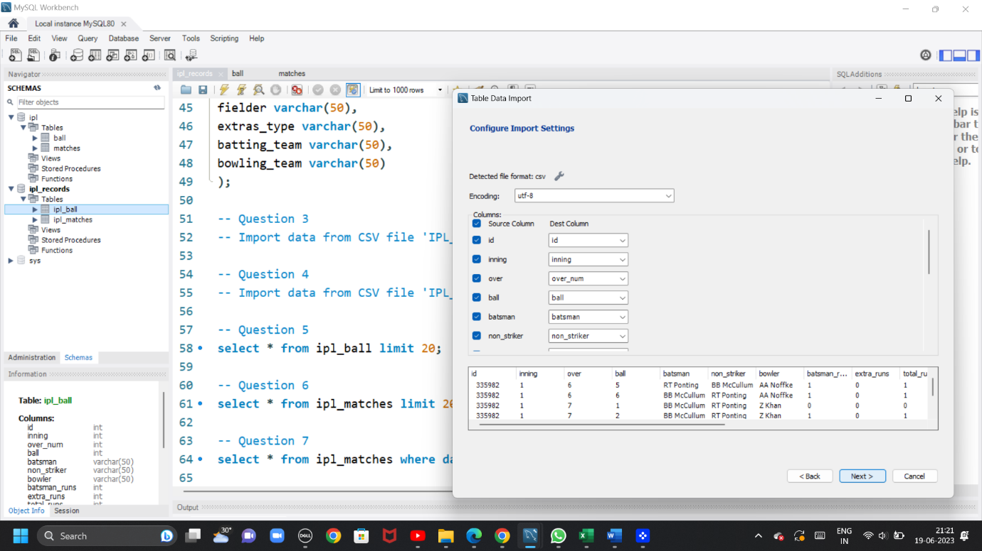



Question 5= Select the top 20 rows of the deliveries table.

SELECT * FROM IPL_BALL LIMIT 20;

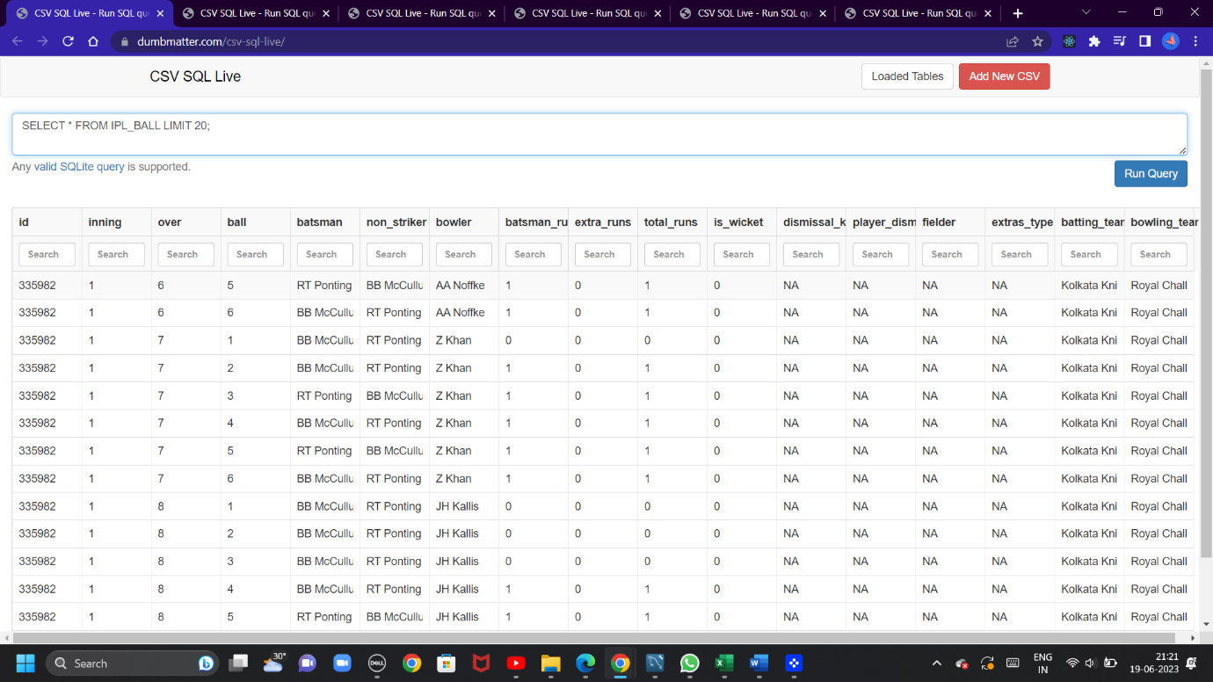

-- Question 6= Select the top 20 rows of the matches table.

SELECT * FROM IPL_MATCHES LIMIT 20;

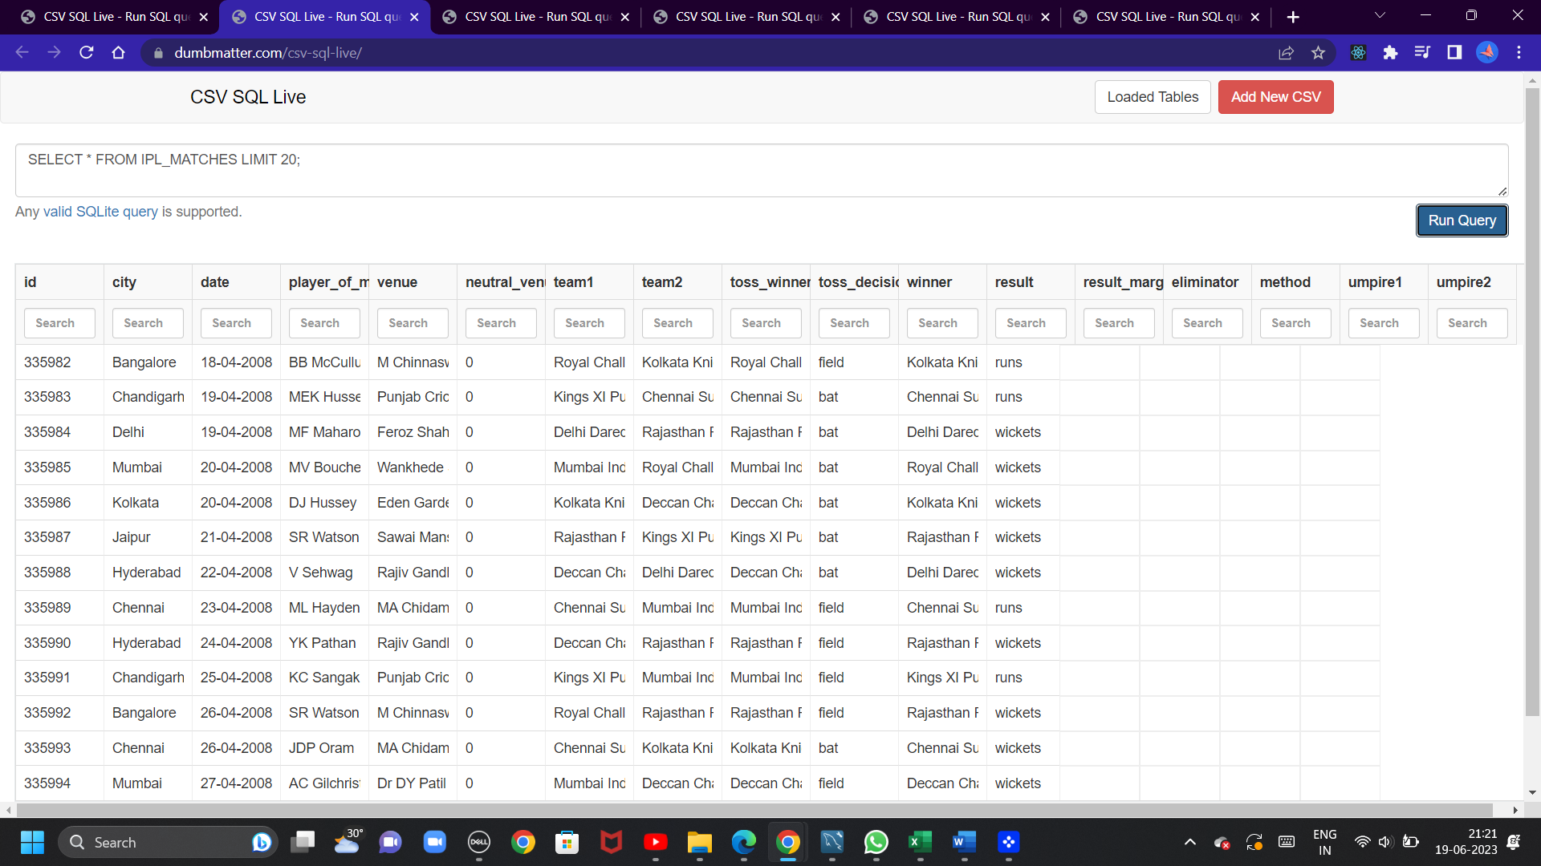

-- Question 7= Fetch data of all the matches played on 2nd May 2013

SELECT * FROM IPL_MATCHES WHERE date = '02-05-2013';

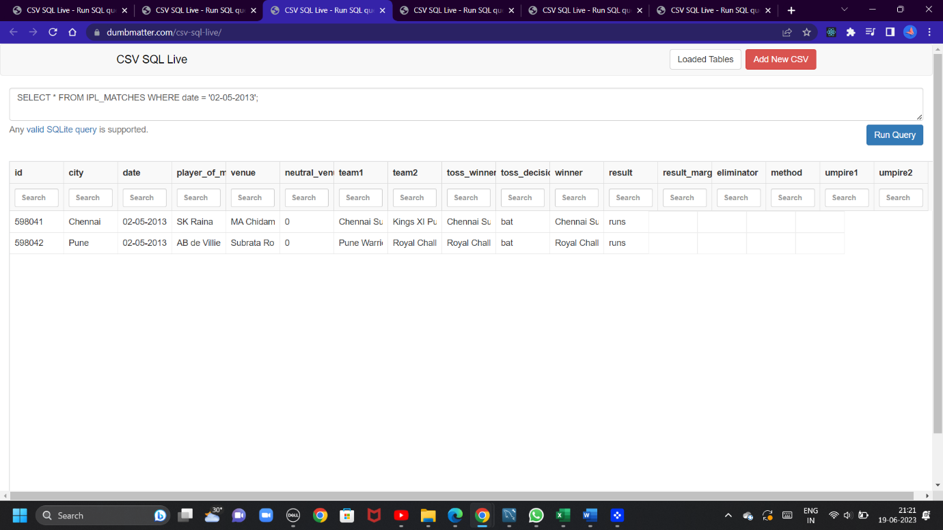

-- Question 8= Fetch data of all the matches where the margin of victory is more than 100 runs.

>select * from IPL_MATCHES where result_margin>100

order by date desc;

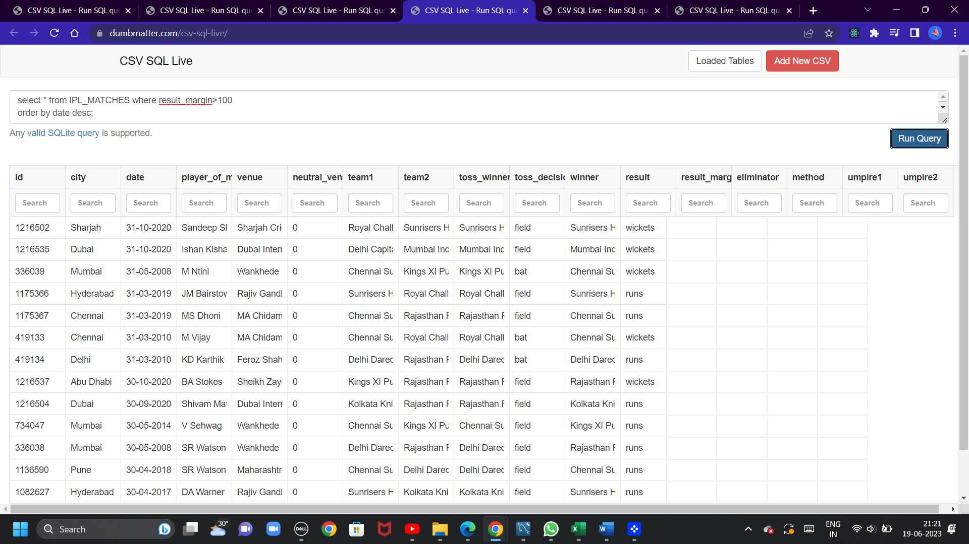

-- Question 9=. Fetch data of all the matches where the final scores of both teams are tied and order it in descending order of the date.

select * from IPL_MATCHES where result='tie'

order by date desc;

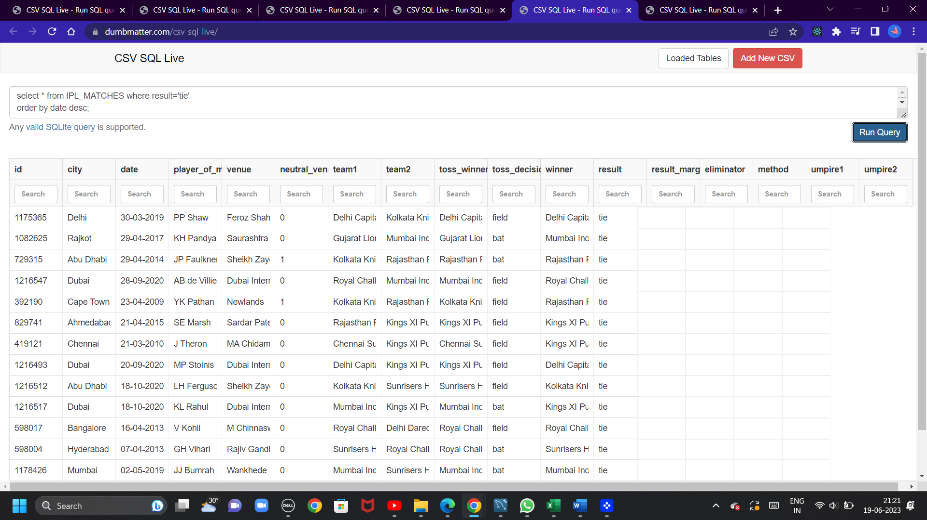

-- Question 10= Get the count of cities that have hosted an IPL match.

select city, count(city) as count_of_city from IPL_MATCHES

group by city

order by count_of_city desc;

